TC-DISP-028
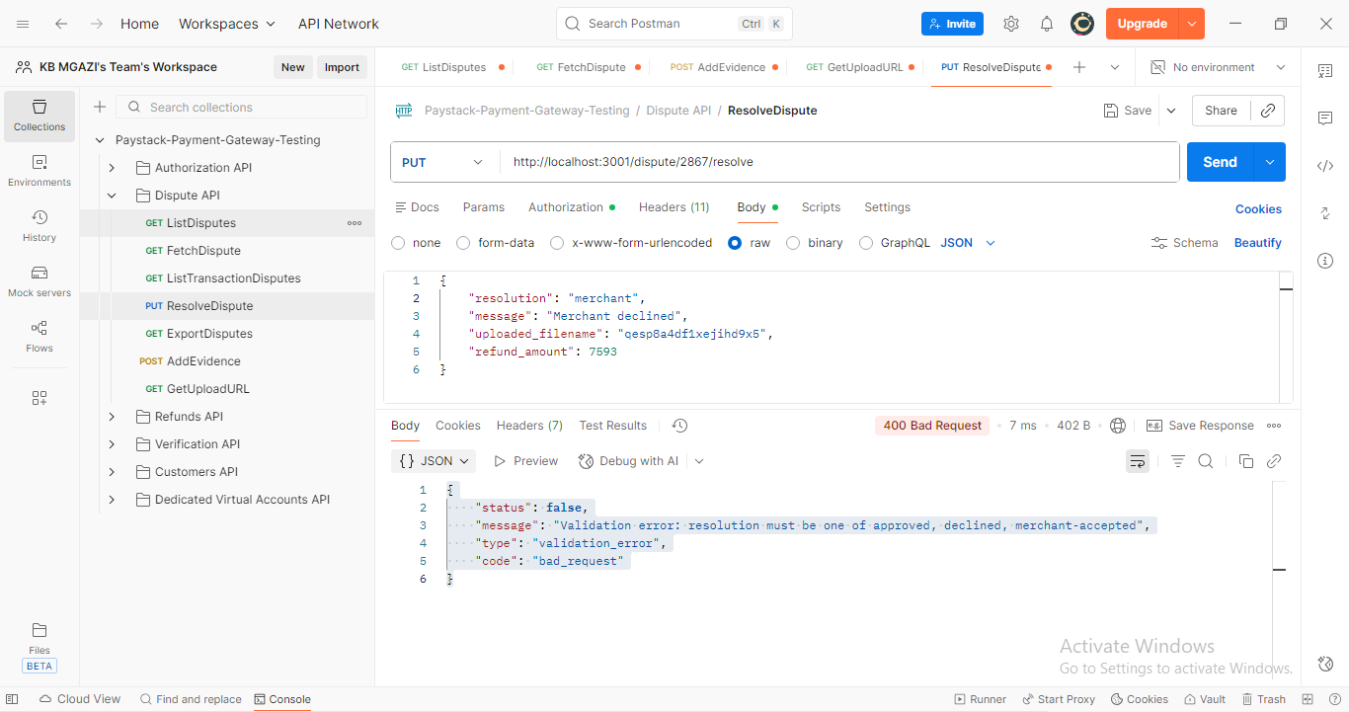
Request:
{
"resolution": "merchant",
"message": "Merchant declined",
"uploaded_filename": "qesp8a4df1xejihd9x5",
"refund_amount": 7593
}

Response:
{
"status": false,
"message": "Validation error: resolution must be one of approved, declined, merchant-accepted",
"type": "validation_error",
"code": "bad_request"
}

